A Complete Guide of Automatic Transfer of Quality Module Test Results to Inventory Module to Item Batch Attribute Values

Applies to: Dynamics 365 Finance, Dynamics 365 Supply Chain Management
This article describes how to do the required setups so that test result values of quality order test are automatically transferred respective item batch attribute values. No manual intervention is needed.
This functionality is very much important for those business that handles items along with their batches. Each batch has multiple variables, and each variable will have it’s own batch value. The attribute values are generally determined by testing the respective batch in laboratory which will find out the exact value of the attribute for that batch.
For example, think about density of milk. Each batch of milk will have different density values. This density value is found in lab and has to be updated to batch attribute. But this interesting functionality will automatically transfer all the test result value of the batch to respective batch attributes without any human intervention. Think about a scenario where there are tens of parameters for each value and one has to handle multiple batches in a day which will make this update through manual a humongous process.
This business process to be defined for organizations that have different batches of item created and each item has various attributes which has to be captured and stored for business and compliance purpose. This process to be defined during solutioning process to decide how many attributes needed for batch of the item and how many of them are determined in quality lab. This is applicable for both purchased products or produced products.

Stakeholders

Many people in your organization should be involved in the decision-making and design of the Automatic Transfer of Quality Module Test Results to Inventory Module to Item Batch Attribute Values business processes. Here are some examples of such stakeholders: Production Manager, Quality Manager, SCM Manager, Purchase Manager and inventory manager

Automatic Transfer of Quality Module Test Results to Inventory Module to Item Batch Attribute Values process flow
The following diagram illustrates the business process.
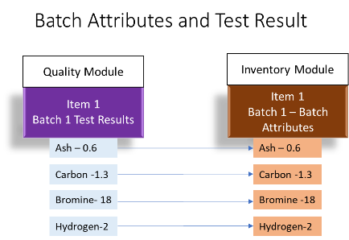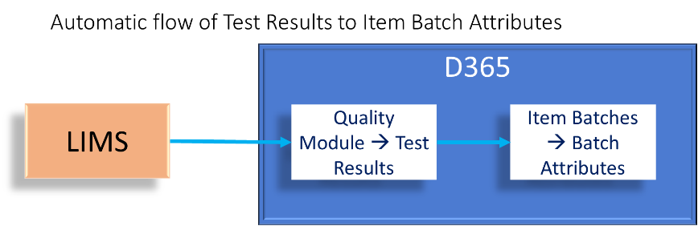
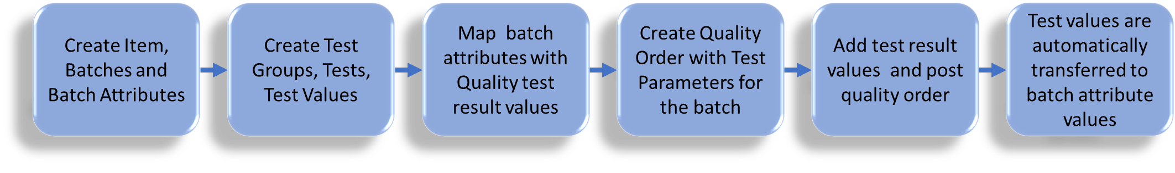
- First step is creation of items, batches and batch attributes.
- On the other hand test groups, tests and test values to be defined in quality module
- Next comes the mapping of which batch attribute is linked with which test result
- Now the operational activities of quality order is created ( automatically or manually) for received purchase item or newly produced item.
- When the test results are updated in quality order and posted/validated the test values are automatically transferred to item batch attribute.

Implementing Automatic Transfer of Quality Module Test Results to Inventory Module to Item Batch Attribute Values process flow
To implement this business process user has to be ensure batch and batch attribute variables fully setup. Then the user has to initiate the quality module. Also the quality associations for purchase and production to be setup if quality orders are to be initiated automatically. In addition all quality order related setups such as Test Groups, Tests, Test Variables, Test Instrument, Item Sampling are setup properly. Then comes the implementation of mapping batch attributes and its corresponding test variable. Thes are the various setups required before quality order is created, results added and validated.
The steps are detailed below.
Step 1: Product information management > Setup > Categories and attributes > Batch attributes.
The batch attributes is used to define, configure, and manage batch-specific attributes. Batch attributes help organizations track quality, compliance, material properties, and any values that vary from batch to batch. Common industries using these include food & beverage, chemicals, pharmaceuticals, steel, and any batch-controlled manufacturing.
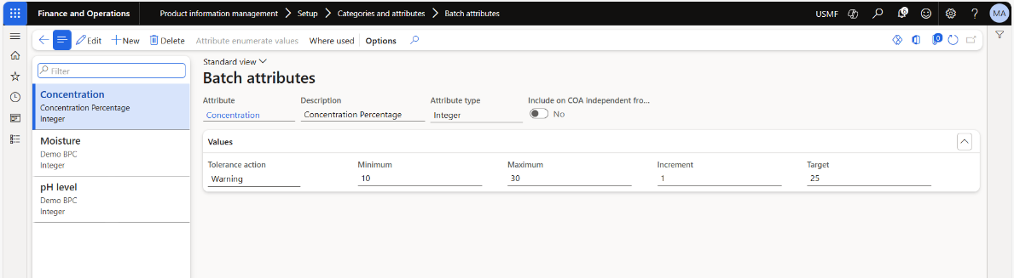
Step 2: Assign these attributes to released products
Step 3: Setup Test groups in inventory management. Inventory management > Setup > Quality control > Test groups
Test Groups in D365 F&O are bundles of quality tests that must be executed together as part of a quality order. They define what tests apply, how they apply, and under what sampling rules.
Step 4: In this test group select the attribute field to be mapped to test so that the result should be updated by the test automatically
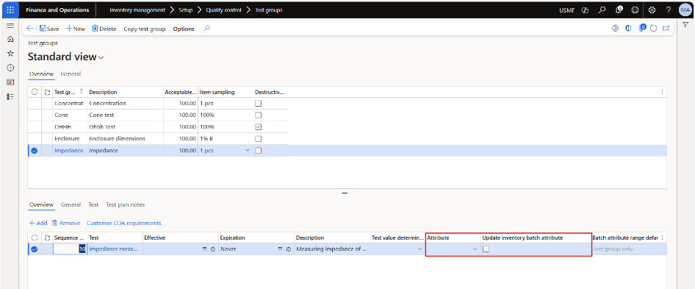
Step 5 : Inventory management > Setup > Quality control > Quality associations.
A Quality Association in D365 F&O is a rule that determines when the system should automatically create a quality order, and which tests, sampling plan, and AQL should be used for that order.
Step 6: Create the quality order, update test results and validate. The batch attribute values are update automatically

Module details of Automatic Transfer of Quality Module Test Results to Inventory Module to Item Batch Attribute Values

Product Name | Module/Feature Name
D365 F & O | Product Information Management
D365 F & O | Inventory Management
D365 F & O | Procurement and Sourcing
D365 F & O | Production Management
D365 F & O | Quality Management

[¹WARNING: You can add these later, but the original value cannot be changed.]
[²CAUTION: This configuration cannot be changed after transactions exist. ]

Next steps

If you want to implement Dynamics 365 solutions to assist with your Automatic Transfer of Quality Module Test Results to Inventory Module to Item Batch Attribute Values , you can use the following resources and steps to learn more. (Links are added, when the articles are ready.)
- Automatic Transfer of Quality Module Test Results to Inventory Module to Item Batch Attribute Values
- https://learn.microsoft.com/en-us/dynamics365/supply-chain/inventory/quality-orders
- https://learn.microsoft.com/en-us/dynamics365/supply-chain/pim/tasks/create-batch-attributes-product

/Related patterns

Related resources

You can use the following resources to learn more about the Automatic Transfer of Quality Module Test Results to Inventory Module to Item Batch Attribute Values process in Dynamics 365.
- https://learn.microsoft.com/en-us/dynamics365/supply-chain/inventory/quality-orders
- https://learn.microsoft.com/en-us/dynamics365/supply-chain/pim/tasks/create-batch-attributes-product

Tags
Industries: Agriculture (01-09), Mining (10-14), Manufacturing (20-39), , Retail Trade (52-59), Finance, Insurance,
Stakeholders: Accounts payable, Accounts receivable, Administrative, Finance, Human Resources, IT, Operations, Production, Purchasing, Sales, Warehouse
Products: Dynamics 365 Finance Dynamics 365 Supply Chain Management

Contributors
This article is maintained by Microsoft. It was originally written by the following contributors.
Principal author:
- [Mohammed Raffe Samathu]( https://www.linkedin.com/in/raffe-m-s-8967a7291) | Industry Principal Consultant
- [Infosys ]( https://www.infosys.com/services/microsoft-dynamics.html ) | [premier Global Systems Integrator (GSI) partner]
Other contributors:
None

